Warehouse Management System
Current layout:
Scenario 1 (Staging): You have a piece of paper that tells you what pallets a truck needs on it, then you go to each location in the warehouse (IE: Aisle E Bay 68) and pick the pallet could be 1-24 pallets, then you bring it to a staging area where it’ll stay until a loader moves it from the staging area to a truck.
Scenario 2 (Live Loading): Just like staging, except instead of moving it to the staging area, you move it from the bay directly onto the truck.
Scenario 3 (Loading): Move pallets from staging area to the truck.
Scenario 4 (Unloading): You move pallets from the truck to a bay (YOU MUST keep all of the same batch numbers together, so if 5 trucks of the same stuff come in, they must be gathered in the same bay, or start a new bay if the old bay reaches capacity, but you cannot mix a batch with another batch)

**Problems**
Scenario 1: The paper tells you to grab 1 pallet from Aisle E 68, but you accidentally grab 1 pallet from Aisle E 66. There is nothing that indicates you grabbed the wrong pallet. It will accept the pallet and then you load it and it costs the company $2,000 for a shipping error.
Scenario 2: Same as the scenario 1 problem.
Scenario 3: You are supposed to load staging area 5 into dock door 5, but you accidentally load staging area 4 into dock door 5, there is nothing that indicates this, because there is no scanning happening during this task.
Scenario 4: You aren’t scanning each pallet from the truck into the bay. Let’s say you are supposed to put a truck into Aisle C Bay 20, but you accidentally put 2 cases in Aisle C Bay 22 by mistake. This will cause inventory tracking issues. Another problem with unloading is, since you're not scanning anything, it's not tracking the bay's capacity, thus meaning if someone comes behind you and is staging ( or it's being used on the production line ) and withdraws from your bay without you seeing it or knowing, it can lead to a miscounted bay.

Solutions:
Scenario 1: Implement a verification step, if you scan the wrong pallet, it’ll tell you and it won’t let you move on until you have fixed the problem.

Scenario 2: Same as scenario 1 solution.

Scenario 3: You must manually scan each pallet, start by scanning the door. Then it will read on the scan gun 0/24, as you scan each pallet it will show 1/24, 2/24, etc. If it is incorrect and the pallet doesn’t belong on this door, then it will reject the pallet. (The doors would obviously be changed based on the shipping clerk manually entering the order number assigned to whatever door he has the driver pulling into.)

Scenario 4: Scan each pallet from the truck into the bay. You would scan the bay to start with, it would display the number of pallets in the bay, starting with 0/72, then each time you scan a pallet, it’ll go up one, 1/72, 2/72, etc.

Extra Features:
Route optimization: When staging, you are given a paper list with several different locations to grab pallets out of. I would like the scan gun to show each location, top to bottom, categorizing sizes of the pallets for fork leveling, and for location of each pallet, making travel time way less.
Track staging areas that are available.
Scan verification: it will not let you scan the wrong pallet

Pallet compatibility database: 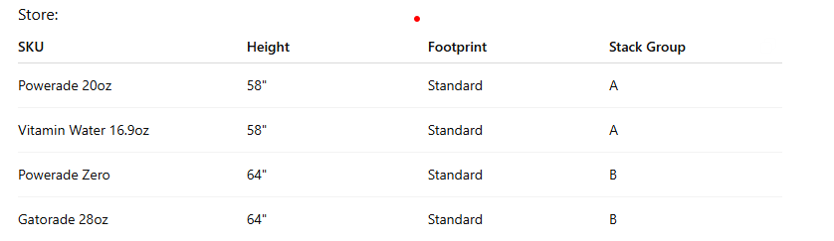
First in = first out, leading to less (if any) expired goods within the warehouse. The route optimization would take this into consideration. We just threw away $20,000 worth of vitamin water because it expired.

Being able to combine bays, move Bay 52 to 54 since there are only 2 pallets in bay 52, taking up a whole bay, you can move it to bay 54 and save a whole bay area. This could work in a sense of "first in first out" as well, since if we're pulling from Bay 52 already, and we move it to 54, then they'll be the first ones loaded out of 54 once the system updates it.
Audit log:
06/12/2026 10:45 AM
User: Chase
Moved:
Vitamin Water Batch 12345
From:
E68
To:
Staging Area 5

End of extra features

GOALS:
Reduce shipping errors
Increase inventory accuracy
Reduce travel time
Improve FIFO compliance
Track bay capacity
Track staging areas that are available

Warehouse Objects:
Bays
Dock doors
Aisles
Products
Inventory
Staging Areas
User
Pallet
Batch
Order

User Types:Permissions
Supervisor: View all inventory, approve adjustments, view reports, manage bays
Forklift Operator: View pick tickets, scan pallets, move inventory, load/unload trucks

Shipping clerk: Create orders, assign dock doors, generate pick tickets
Inventory manager: View all inventory, approve adjustments, view reports, manage bays
Inbound scheduler: ?
Outbound scheduler: ?
Manager: Manage users, system settings, permissions

Inventory Rules
- A pallet must exist in exactly one location at a time.
- A pallet cannot be loaded if it has not been picked.
- A pallet cannot be unloaded into a full bay.
- Inventory counts must update immediately after a move.

Batch Rules
- Different batches cannot be mixed in the same bay.
- If a bay is full, a new bay must be assigned.
- FIFO should be followed whenever possible.

Loading Rules
- Pallets must be verified before loading.
- A pallet assigned to Door 5 cannot be loaded to Door 4.
- Loading progress should be tracked (e.g., 12/24 pallets loaded).

User Rules
- Forklift operators cannot modify users.
- Shipping clerks can create orders.
- Supervisors can approve inventory adjustments.

GUI REQUIREMENTS:
Login Screen
- Username
- Password
- Login button
Dashboard
- Active orders
- Inventory alerts
- Expired product warnings
Pick Ticket Screen
- Order number
- Pick locations
- Scan verification
- Progress counter
Inventory Screen
- Search inventory
- View bay contents
- Move inventory
Loading Screen
- Scan door
- Scan pallet
- Track loading progress
Reports Screen
- Inventory accuracy
- Error reports
- Productivity reports

